6th Grade Band

**You may order from Fullersmusic.com, Amazon or buy at a local music store. Fuller’s Music will deliver free of charge to the school.

All Students
Pencils
Notebook paper
Ear Buds/headphones
Method Book – Tradition of Excellence (Nowlin & Pearson) Book 1 (Red Book with student instrument on the front)
(Flute/Clarinet/Saxophone/Trombone/Trumpet - $10.95, Horn - $11.95, Percussion - $13.50)

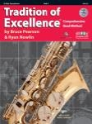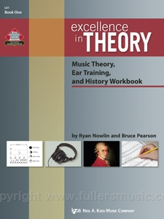

Theory Book – Excellence in Theory (Nowlin & Pearson) Book 1 (all books $7)

Flute
- Cleaning Rod (should be included with the instrument)
- Cleaning swab ($10)

Clarinets and Saxophones
- At least 4 working reeds at all times. Recommended reeds are Mitchell Lurie or Vandoren. (Price varies on size and type of reed.)
- Reed Guard IV for reed storage ($5)
- Cork grease (should be included with instrument)

Trumpets and Trombones
- Valve Oil (should be included with instrument)
- Slide grease ($3.50)

Percussion
- Drum Stick Bag (approx.. $15)
- Vic Firth General SD1 Snare Sticks (approx. $10)

7th Grade Band

**You may order from Fullersmusic.com, Amazon or buy at a local music store. Fuller’s Music will deliver free of charge to the school.

All Students
Pencils
Notebook paper
Ear Buds/headphones
Method Book – Tradition of Excellence (Nowlin & Pearson) Book 2 (Blue book with student instrument on the front)
(Flute/Clarinet/Saxophone/Trombone/Trumpet - $10.95, Horn - $11.95, Percussion - $13.50)

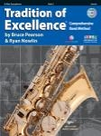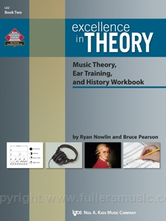
Theory Book – Excellence in Theory (Nowlin & Pearson) Book 2 (all books $7)

Flutes
- Cleaning Rod (should be included with the instrument)
- Cleaning Swab ($10)
- Recommended – Care Kit $20 and includes all cleaning materials

Reed Instruments
- At least 4 working reeds at all times. Recommended reeds are Mitchell Lurie or Vandoren. (Price varies on size and type of reed.)
- Reed Guard IV for reed storage ($5) – Do not need if already have this.
- Cork grease (should be included with instrument) – May need to be replaced.
- Cleaning Swab ($10)
- Recommended – Care Kit $20 and includes all cleaning materials

Brass Instruments
- Valve Oil (should be included with instrument) – May need to be replaced.
- Slide grease ($3.50)
- Recommended – Care Kit $20 and includes all cleaning materials including brushes to clean slides.

Percussion
- Drum Stick Bag (approx. $15) – only if need to replace
- Vic Firth General SD1 Snare Sticks (approx. $10) – only if need to replace
- Innovative Medium-Soft Yarn Marimba mallets IP 240 (approx. $33) – only if need to replace.

8th Grade Band

**You may order from Fullersmusic.com, Amazon or buy at a local music store. Fuller’s Music will deliver free of charge to the school.

All students
Pencils
Notebook paper
Ear Buds/headphones
Method Book – Tradition of Excellence (Nowlin & Pearson) Technique and Musicianship
(All instruments $10) (Golden colored book with a collection of instruments on the cover)

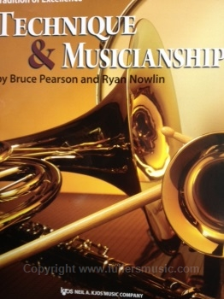
Flutes
- Cleaning Rod (should be included with the instrument)
- Cleaning Swab ($10)
- Recommended – Care Kit $20 and includes all cleaning materials

Reed Instruments
- At least 4 working reeds at all times. Recommended reeds are Mitchell Lurie or Vandoren. (Price varies on size and type of reed.)
- Reed Guard IV for reed storage ($5) – Do not need if already have this.
- Cork grease (should be included with instrument) – May need to be replaced.
- Cleaning Swab ($10)
- Recommended – Care Kit $20 and includes all cleaning materials

Brass Instruments
- Valve Oil (should be included with instrument) – May need to be replaced.
- Slide grease ($3.50)
- Recommended – Care Kit $20 and includes all cleaning materials including brushes to clean slides.

Percussion
- Drum Stick Bag (approx. $15) – only if need to replace
- Vic Firth General SD1 Snare Sticks (approx. $10) – only if need to replace.
- Innovative Medium-Soft Yarn Marimba mallets IP 240 (approx. $33) – only if need to replace.
- Innovative Medium Plastic Xylophone mallets IP 902 (approx. $29)

